Data Center Heat Reuse in the
  - David Gardiner and Associates
Petter Terenius

August 2025

Food & Beverage Sector

Pre-Commercial Feasibility Study

  - David Gardiner and Associates
David Gardiner, Emily Kent, Hannah Schuster, Oren Lieber-Kotz
With: Dr. Priscilla Johnson and Petter Terenius

October 2025
Table of Contents
I. Executive Summary 3
II. Background 4
Policy Environment 5
The European Food & Beverage Sector 6
III. Proximity Analysis 7
Key Takeaways 7
Proximity Analysis Methodology 9
IV. Business Case Analysis 9
Key Takeaways 10
Business Case Overview 11
Case Study 1: Germany 19
Case Study 2: United Kingdom 21
Case Study 3: The Netherlands 23
Case Study 4: Spain 24
Case Study 5: Sweden 26
Beyond 8 MW 28
V. Interviews with Potential Food & Beverage Offtakers 29
Methodology 29
Key Takeaways 29
Company Overviews 33
VI. Conclusion 34
VII. Appendix 35
Heat Reuse Flow Diagrams 35

Executive Summary
Microsoft is interested in deploying data center heat reuse projects at its facilities in Europe. This energy-saving approach can support the company as it expands artificial intelligence (AI) computing across Europe while, simultaneously, working to reduce its carbon emissions. This report from David Gardiner and Associates (DGA) is a pre-commercial feasibility study investigating Microsoft’s heat reuse potential in the food and beverage (hereafter, “food & beverage” or “F&B”) industry.
The overarching takeaway from DGA’s research is that data center waste heat is both technically and financially viable as an energy solution, and there is substantial interest among potential offtaker partners in the food & beverage sector.
The report first provides a proximity analysis that quantifies the distance between Microsoft data centers and food & beverage manufacturing facilities in Europe, concluding that roughly half of Microsoft’s 26 European sites are located within three kilometers (km) of a potential food & beverage offtaker. All 26 data centers are within 10 km of a manufacturing site—which is a promising sign for Microsoft’s ability to find project partners in this sector. Additionally, many of these food & beverage sites are large scale, according to DGA’s analysis of total employee numbers at the facilities. The median F&B site within 3 km of a Microsoft data center has 106 employees.
Second, the report includes a business case analysis which determined that data centers could see payback periods of less than a year and F&B offtaker facilities could see payback periods ranging from two to five years (depending on real-world conditions and technical and financial project setup). The analysis of data center costs includes factors such as the development of a heat exchange room on its premises and relevant financial incentive programs. The F&B offtaker analysis includes factors like the cost of heat pumps to raise the temperature of Microsoft’s liquid output and the savings from avoided natural gas costs. Offtaker interest in projects may be increased for scenarios where DGA found particularly low offtaker payback periods (e.g., less than 3 years).
The business case analysis is primarily focused on a scenario where the waste heat output from Microsoft’s data centers is 30 degrees Celsius (°C), as this reflects current conditions. However, DGA also explores a future scenario where the waste heat is 65 °C. This results in several changes to the cost analysis; for example, some projects may not need a heat pump, which could make the project more attractive to an end user.
Finally, the report provides insights from potential offtakers based on interviews DGA conducted with seven leading food & beverage manufacturers in Europe. The interview subjects near-universally expressed interest in exploring heat reuse opportunities with Microsoft. These seven companies prioritize sustainability—all but one have targets with the Science Based Targets Initiative (SBTi) and all are members of the DGA-run initiative, the Renewable Thermal Collaborative—so, as a group, they demonstrate substantial willingness to seek out innovative climate solutions.
All seven interviewed companies have at least some use for low-temperature heat, such as cleaning processes that require water in the 60-80 °C range. These applications would require heat pumps to lift the temperature of Microsoft’s current liquid output, but—crucially—all seven of the companies have implemented heat pumps at least one European location. Several expressed to DGA that they prioritize any opportunity to reuse their own waste heat. Most interviewed companies told DGA they require a payback of approximately three years on capital projects—though several also noted flexibility if a project provides climate benefits or other innovations.
As Microsoft seeks out future partners for waste heat projects, it will be helpful if the company can clearly demonstrate both the financial and climate benefits for offtakers (i.e., avoided natural gas costs and reduced carbon emissions). As demonstrated through our analysis, it is technically and financially feasible to provide data center heat to offtaker facilities, potential facilities in the F&B industry exist nearby Microsoft data centers, and multiple F&B companies are ready for further exploration with Microsoft.

Background
Data centers are driving a major increase in energy demand across Europe, with the sector’s overall demand projected to reach 36 gigawatts (GW) by 2030. New hyperscale facilities are helping to drive the growth. Microsoft has stated it intends to roughly double its European data center capacity between 2023 and 2027, at which point it will have more than 200 facilities operating across the continent.
Companies, like Microsoft, that are growing their footprint but have also committed to ambitious clean energy goals, need new strategies to curb power generation. Heat reuse is a win-win opportunity for Microsoft and its offtaker partners. By establishing a circular closed-loop system, the end user gets an alternative to natural gas for all or a portion of its operations, and the data center can expect to lower its power consumption by 10% to 30%.
For many reasons, this is an ideal time to push forward with waste heat projects; those reasons include price volatility in fossil fuel markets and the imperative to combat global climate change. Additionally, laws and regulations in European countries are requiring, or moving towards requiring, heat reuse at data center facilities.

Policy Environment
Heat Reuse Regulations and Support
DGA chose to focus its analysis on Europe—where policymakers have been increasingly focused on opportunities to improve efficiencies and reduce energy consumption in the data center industry—and based on interest from Microsoft in the region.
One of the most prescriptive pieces of legislation comes from Germany. The German Energy Efficiency Act (2023) requires new data centers with annual energy consumption above 15 gigawatt hours (GWh) to reuse an increasing percentage of their heat. The law also requires these facilities to document and publish their energy efficiency measures.
In the Amsterdam region in the Netherlands, new data centers must meet energy efficiency standards, which includes meeting specific Power Usage Effectiveness (PUE) ratings. Heat reuse may be a tool to support those efforts.
The European Union (EU), meanwhile, has taken its own action. The EU Energy Efficiency Directive (EED), for example, includes a suite of regulations that promote energy efficiency across member states. One provision states that countries “shall encourage” the owners and operators of data centers of at least 1 megawatt (MW) to “take into account” best practices from the European Code of Conduct on data Centre Energy Efficiency, which includes a section on heat recovery and reuse to satisfy surrounding heat demands.
Beyond specific requirements to deploy or consider waste heat reuse, European policymakers have taken other steps to support the deployment of these projects. One key way governments have offered support is by creating matching platforms that help data centers find partners with compatible heat needs. Examples of such platforms include the EU Heat and Cold Matching Platform and the German Bytes2Heat Matching Tool, which was funded by the Federal Ministry of Economics and Climate Project. There are multiple platforms in Ireland, including the Heat Atlas which has a map of potential offtakers and district energy networks, and Codema which provides maps specific to Dublin.
EU Trading System
EU carbon emission regulations may also impact interest in data center heat reuse. Most industrial emissions in the EU are regulated under the EU Trading System (EU ETS), which is a cap-and-trade program that sets a limit (cap) on total greenhouse gas (GHG) emissions from certain sectors. Companies receive or buy emission allowances, each permitting the release of 1 ton of carbon dioxide (CO₂). If a company emits more than its allowances, it must buy extra allowances or reduce emissions. In essence: the more one emits, the more one must pay.
The EU ETS scheme is only applicable to facilities with a combined rated thermal input that is at least 20 MW, which may not be relevant for smaller data centers. But it could be of interest for future, large-scale Microsoft locations and is included in the data center economic analysis in Section IV. The EU ETS is excluded from the F&B facility analysis, as the F&B facilities selected for analysis do not meet the 20 MW heat threshold.

The European Food & Beverage Sector
There are many strong use cases for data center heat reuse across a variety of sectors, including food & beverage, pharmaceuticals, and commercial cooling. For this report, DGA chose to focus specifically on the food & beverage industry, which is among the top three largest employers in many European countries.
The overall thermal needs of food & beverage facilities tend to max out around 8-10 MW, including industrial cooling. Heat demand typically constitutes two thirds of the site’s total need.
DGA determined that many F&B facilities would have heating applications below 100 °C that are compatible with a data centers’ liquid output, such as pasteurization of dairy products, washing/cleaning, and other process heat applications. Other common applications—like baking, for example—require much higher heat and would not be a good fit for data center heat reuse, though if temperature outputs from Microsoft sites increase, more use cases will become viable.
These facilities are likely to require heat pumps to lift the data center heat to meet their needs. In the Net-Zero-Emissions scenario developed by the International Energy Agency, heat pumps will supply 30% of the heat demand at low to medium temperature levels in light industries, especially the "food, beverages, and tobacco" industry, by 2050. The food & beverage segment holds the largest market share in industrial heat pumps, accounting for approximately 37.5% of the global market in 2023, with demand driven by the need for efficient heating solutions in processes such as pasteurization, drying, and fermentation. This current and future openness to heat pumps also makes the F&B industry a good fit for data center waste heat reuse.
Another reason DGA chose to focus on food & beverage is that many leading companies have committed to aggressive reductions in carbon emissions. Additionally, EU policies are pushing industrial facilities to decarbonize and shift away from natural gas, which should make companies more open to partnership with Microsoft.

Proximity Analysis
Proximity is a central consideration in any heat reuse project. The closer that an offtaker is located to a data center, the easier it is to transport the heat. DGA’s proximity analysis uses QGIS software to determine the proximity of Microsoft data centers to potential offtakers in the food & beverage sector, specifically identifying industrial-scale manufacturing facilities within three km of a Microsoft site.

Key Takeaways
The proximity analysis identified two key factors relevant for Microsoft’s planning. First, it found that, out of 26 Microsoft data centers in Europe, 50% are within 3 km of a food & beverage manufacturing site—a promising sign for the viability of future Microsoft projects. Furthermore, 23% of data centers are within 1 km of a manufacturing site, and all data centers are within 10 km of a manufacturing site, as indicated in Figure 1.
The average distance to the closest F&B manufacturing site is 3.43 km.
Figure 1. Portion of European Microsoft Data Centers within 3 km of a Food & Beverage Manufacturing Site.

(Percentages show the proportion of Microsoft data centers in Europe at the given distance from a F&B manufacturing site.)
Figure 2. Number of Food & Beverage Manufacturing Sites within 3 km of a Microsoft Data Center

Second, the proximity analysis found that many F&B facilities close to Microsoft data centers are large and, thus, represent potentially strong heat offtakers. As the business case analysis will explore in more detail, the scale of an offtaker facility’s heating needs is another relevant factor when determining feasibility of a certain project. Because F&B facility heat use is not public, DGA used the number of employees as a proxy to assess whether the food & beverage facilities near Microsoft data centers are industrial scale. The median F&B manufacturing site within 3 km of a Microsoft data center has 106 employees, indicating significant size and scale. A single facility owned by Mars, Inc., which is approximately 350 meters from the Equinix LD5 data center in London, employs 1400 people.
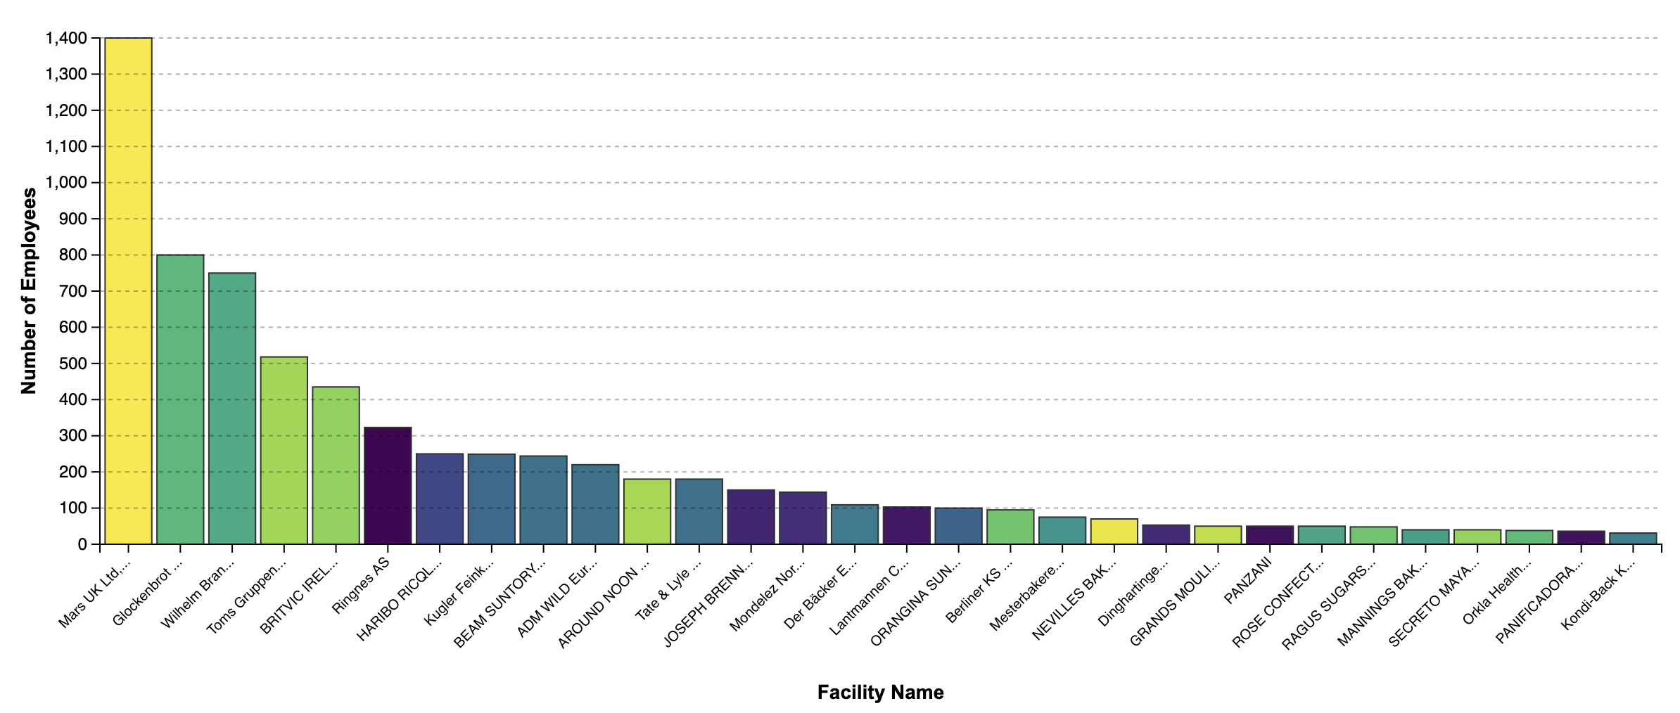
Figure 3. F&B Manufacturing Sites within 3 km of a Data Center, by Number of Employees

Proximity Analysis Methodology
The analysis determined data center locations by using TeleGeorgraphy’s Cloud Infrastructure map and compiled a list of food & beverage manufacturing sites using two sources, one providing a more targeted set of datapoints and the other a broader set. The narrower European Pollutant Release and Transfer Register (E-PRTR) catalogs sites that report pollutant releases in Europe exceeding certain thresholds. To distinguish food & beverage sector manufacturing facilities, DGA filtered the E-PRTR database for facilities reporting under the Industrial Activity (IA) sector code 8.(b) – “Animal and vegetable products from the food and beverage sector.”
The broader dataset came from the Dun & Bradstreet Hoover (DnB) business intelligence database. DGA conducted a search for companies with sites which were: within two miles of Microsoft data centers in Europe; employed at least 25 people (to rule out small or errant sites); and were listed with food & beverage manufacturing codes. More detail on the specific codes used to select F&B manufacturing facilities can be found in the full Proximity Analysis deliverable.

Business Case Analysis
The following is a business case analysis that explores the financial feasibility of data center heat reuse projects where Microsoft partners with food & beverage sector offtakers.
The analysis includes an overview of the financial and technical setup for heat energy reclamation, including the piping, heat pumps, and heat exchangers needed to establish a closed-loop thermal system where water circulates from the data center to the end user and back. DGA explores two scenarios for the output temperature of Microsoft’s waste heat: a primary scenario using 30°C and an additional 65°C scenario.
DGA's analysis examines the business case from both Microsoft's perspective as well as the potential offtaker's perspective. Each party has different costs to consider, which will result in different CAPEX and OPEX requirements and savings, and thus different payback periods. For example, the data center’s costs and savings are not included in the offtaker’s payback period.
The report also introduces five real-world case studies, partly based on identified potential offtakers in the project’s Proximity Analysis. In this report, these use cases serve as templates rather than concrete recommendations, but they may be regarded as potential candidates for Microsoft’s heat reuse projects.

Key Takeaways
- Data centers could expect to see short payback periods—depending on technical and financial setup, potentially even less than 1 year—due to the significant operational cost savings from avoided electricity use in comparison to the necessary capital expenditures (CAPEX).
- The payback periods for an offtaker vary considerably across the five scenarios, but with favorable pricing, offtaker payback periods should range from two to five years. The actual payback period is dependent on a number of factors, including the project’s technical setup, local electricity pricing, avoided natural gas and carbon tax, and the possibility of other subsidies. Therefore, the calculations should only be viewed as indicators for potential cases.
- Average offtaker CAPEX across scenarios would be around 9 million euros (€). This includes the offtaker expense for heat pumps, storage tanks, heat exchangers, and piping/trenching. It does not include the heat exchange room of the data center. The main cost driver is the need for heat pumps to raise the temperature of the data centers’ heat output. Where there is secondary use for warm water (washing etc.), and a second heat pump is avoidable, CAPEX is considerably lower. In relative terms, piping/trenching costs are minimal.
- The thermal energy needs of most large F&B facilities seem to top out at 8-10 MW. Hence, this is the power range that Microsoft can hope to address and that the analysis focuses on. Though this figure is low in comparison to the thermal output of many of Microsoft’s data centers, there may be opportunities for the company to maximize its heat reuse potential, such as supplying heat to an industrial park.
- Europe is trending away from natural gas, and toward renewable or industrial thermal energy. Of special interest to this analysis is the trend of increasing gas prices. For the offtaker, heat pumps win over gas boilers across all five use cases on operational expenses (OPEX) alone, despite higher electricity prices. The efficiency advantage (Coefficient of Performance, or COP) of heat pumps is the game-changer: one gets three times the heat output per unit of electricity. Carbon pricing further heavily penalizes gas boilers, especially in the Nordics.
As the use cases show, the possibility to heat a food & beverage facility with data center waste heat is both real and substantial. It is impossible to know what of the facility’s existing infrastructure (such as heat pumps) can be used in these scenarios. Likewise, DGA cannot know the facilities’ actual heat demands known, nor the facility’s financials (energy expenses, exact subsidies in place, etc.). It is therefore not possible to definitively judge the business case performance for the cases. The only way to move forward would be to contact the companies in question. That being the case, the BCA shows that there are clear possibilities for F&B industries to serve as partial offtakers of Microsoft’s heat offerings, across Europe.

Business Case Overview
The first goal of this Business Case Analysis is to identify the main financial elements of a closed-loop heat reuse system, which will help Microsoft to determine the feasibility of moving forward with waste heat projects. There are three main components to consider:
- The heat exchange room of the data center,
- The necessary piping to and from offtaker (receiver of the heat energy), and
- The heat pump at the F&B facility (or similar arrangement).
The other factors that influence feasibility of these projects are the total thermal output and temperature of the data center waste heat. DGA’s analysis assumes:
- The fluid output type is water.
- The fluid should return to the data center, from the offtaker, at 18°C or lower.
- The energy load available from the data center is 1-20 MW. According to DGA’s observations, the thermal energy needs of F&B offtakers are likely to top out at 8-10 MW. To obtain 8 MW, DGA assumes that 2.4 MW of electricity are added to 5.6 MW of supplied heat from the data center, for a heat pump COP of 3.3.
DGA’s analysis looks at two different scenarios regarding the temperature output from Microsoft’s data centers:
- A primary scenario where the fluid leaves the data center at 30°C.
- A future scenario where the fluid leaves at a higher output of 65°C.

Heat Supply and Use Scenarios
Descriptions of the heat scenarios are provided below. Visual flow diagrams of the heat reuse scenarios are provided in the Appendix.
- Primary Scenario: 30 °C
In this scenario—which is the primary focus of DGA’s analysis—heat leaves a Microsoft data center at 30°C. Heat pumps are required to lift that heat to 80°C, which is a good benchmark for the temperature requirements of many key processes in the food & beverage industry.
Specifically, two heat pumps can lift water temperature to 80°C, with average temperature lift of approximately 25° per heat pump. Repeated use of the water at the offtaker cools it down before returning to the data center. If the heat has not already reached 18°C—Microsoft’s target return temperature—by this point, it may require a chiller to lower the water temperature a few extra degrees.
In practice, there may be variations in this setup. Perhaps only 75°C is required instead of 80°C, which would lower energy costs. Moreover, Microsoft may want to consider the use of two 4 MW heat pumps instead of each 8 MW heat pump (i.e. a total of four 4 MW heat pumps, instead of two 8 MW heat pumps). It may be possible to install one unit and add another when demand increases.
- Additional Scenario: 65 °C
The advent of high-performance computing leads to higher chip and rack densities. This, in turn, leads to much higher temperatures in the server room. While it is not the primary focus of DGA’s report, our analysis also considers a 65°C scenario. This scenario, in turn, can be varied as well:
Reuse of 65 °C heat at 80 °C
This scenario requires DGA to change some of its assumptions about the piping and offtaker architecture in the following ways:
- Elimination of a second heat pump, since the temperature output is already high. As a result, the whole system becomes leaner and less expensive. (Operating at a higher temperature does require a higher-intensity—and thus more expensive—heat pump, but it is not as expensive as needing two.)
- Addition of a heat exchanger to help regulate and stabilize return temperatures. Doing so ensures that the return temperature to the data center does not exceed a set limit, even if the industrial process sometimes outputs water at a higher temperature.
- Consideration of stainless steel piping instead of high-density polyethylene (HDPE). While DGA’s analysis assumes all cases will use HDPE piping, higher-temperature use cases may see better endurance from the more expensive stainless steel option.
Reuse of 65 °C heat at 64 °C
In this scenario, the temperature is already high enough for many activities in the F&B sector, meaning it could be used as-is, at 65°C (or potentially at 64°C due to minor temperature losses in piping).
This configuration could be highly profitable, as it needs no heat pump. However, this scenario would require a second heat exchanger and an external cooling loop to avoid fluctuations to the return temperature.

Financial Assumptions: Technical Expenses
The following components make up DGA’s financial analysis.
- The Heat Exchange Room
The heat exchange room is part of the Microsoft premises. Because heat reuse is likely to be required in the European market, the heat exchange room is not a major focus on the business case analysis. Still, there are relevant financial considerations involved. It is important to note that when offtaker payback periods are provided in the case studies, they do not include the data center financials.
The following chart compares CAPEX and OPEX costs of a heat rejection system with a system designed for heat reuse, demonstrating that building a heat exchange room for heat reuse leads to substantial savings. Other benefits include:
- Reduced electricity usage because of the elimination chillers and cooling towers.
- Significant water savings due to the lack of evaporation and municipal draw.
- Simpler and cheaper maintenance thanks to the smaller number of compressors, fans, and chemical cycles.
Table 1. CAPEX and OPEX heat exchange room comparison.
Attribute | Heat Reuse Case | Heat Rejection Case | Savings
CAPEX | € 792,000 | € 10,450,000 | € 9,658,000
OPEX | € 220,000/yr | € 3,170,000/yr | € 1.2-3.0M/yr

- Piping and Trenching
The overall cost of piping to transport heat represents a small component of the entire heat reuse system CAPEX. The costs of trenching and installation are also quite low (at least in rural areas with few obstacles), though exact costs can be difficult to estimate.
There are several relevant factors to consider regarding the type of piping used. DGA’s analysis assumes the following:
- Use of HDPE piping material. HDPE is less expensive than stainless steel; it also has a lower carbon footprint and is easier to install. For higher temperatures (i.e. 65°C instead of 30°C), however, stainless steel piping may help minimize temperature loss but would also increase the piping costs over longer distances.
Technical Note
Proximity of data centers of offtakers is a relevant factor in any heat offtaker agreement, but due to the high heat capacity of liquid, heat losses during transportation are relatively minimal. With proper insulation, the temperature drop in water is insignificant over reasonable lengths (much less than 1°C lost over 1 km).

- Piping thickness of 250 mm, as this would provide reasonable pressure in the closed loop.
- Use of insulated pipes when transporting energy to the offtaker but non-insulated pipes when returning heat to the data center. Insulated piping carries additional costs. (Omitting insulation on the return piping helps further lower the temperature of the water, making it more valuable for data center cooling.)
DGA’s analysis assumes these costs for piping:
- €120/meter for an insulated HDPE pipe (to the offtaker)
- €45/meter for an uninsulated HDPE pipe (to return to the data center)
- €100/meter for installation, trenching, and auxiliary parts. Project management and other costs are included in this calculation with minimal effect on overall CAPEX.

- Heat Pumps
To deliver the appropriate temperature to the food & beverage facility, the proposed heat reuse system will require use of heat pumps at the offtaker to raise the temperature of a data center’s heat output. DGA assumes the per unit cost of heat pumps to be € 4,875,000.
DGA’s analysis also assumes the offtaker will be responsible for the expense of purchasing and installing heat pumps.

Assumptions: Outside Financial Factors
Several other factors will impact the feasibility and payback periods for data center heat reuse projects.
- Financial Incentives
In some countries, food & beverage companies may be able to receive financial incentives through energy efficiency or other programs. DGA’s analysis incorporates relevant country-specific incentives in the five case studies. For example, the Dutch program “Stimulating Sustainable Energy Production and Climate Transition (SDE++)” offers subsidies in exchange for carbon reductions, and it explicitly includes waste heat among eligible technologies. Meanwhile, in Germany, a capex subsidy for large-scale heat pumps can cover up to 50% of installation costs.
Additionally, most large-scale industrial emitting facilities in the EU are regulated by the EU ETS; however, the EU ETS scheme is only applicable to facilities with a combined rated thermal input of at least 20 MW. This constraint precludes the selected case study offtaker facilities from participating, as they do not meet this requirement. The data center economics, on the other hand, may benefit from the EU ETS, if they have a thermal input of at least 20 MW. The EU ETS is included in the operational cost savings for the data center by selling credits into the EU ETS program. While these savings may not be accessible to all data centers, larger Microsoft facilities may be able to benefit financially from them.
In addition to the EU ETS, data centers may also be eligible for other financial incentives; DGA’s analysis includes such country-specific incentives where relevant.
- Electricity and Fuel Prices
Electricity: Prices will factor into DGA’s overall business case analysis; specifically, data centers use electricity in the heat exchange room but reduce their overall electricity costs. DGA assumes, however, that offtakers will be responsible for electricity costs associated with heat pumps at their facilities, which factors into the offtakers’ payback periods.
Gas: Offtakers that implement heat reuse will be able to avoid the need for natural gas boilers to support at least a portion of their operations, thereby lowering their natural gas use and costs. These costs will influence payback periods for the offtakers, and avoided fuel expenses will be central to offtakers’ level of interest in these projects. Avoided gas expenses play a key role in the resulting offtaker payback periods. Gas prices do not play a role in the data center’s economics.
Table 2. Current electricity and natural gas prices by country.
Country | Electricity Price (€/MWh) | Natural Gas Price (€/MWh)
Germany | 50 (normally 180) | 71
UK | 140 (for large industries) | 78
Netherlands | 100 (for large industries) | 62
Spain | 90 (for large industries) | 52
Sweden | 90 (for large industries) | 109

Identifying Offtaker Energy Needs
There are several reasons the European food & beverage sector is a good fit for data center waste heat projects. It is large, ranking among the top three employers in many European countries, and DGA’s Proximity Analysis identified several potential F&B offtakers within 3 kms of Microsoft’s existing data centers. F&B facilities use large amounts of heat (heat demand typically constitutes two thirds of the total need), and that heat demand is often low- to medium-temperature.
DGA’s analysis also identifies several challenges:
- Few F&B facilities can match the amount of heat available from large scale or hyperscale data centers. DGA finds it is rare for any F&B facility to have thermal energy needs above 8-10 MW, even when accounting for industrial cooling.
- Some F&B facilities require high temperatures (e.g. for baking or drying), meaning that heat energy from data centers is not a good match. However, this is only a portion of F&B processes.
The table below shows subsectors of food & beverage manufacturing, along with their typical assumed heat needs and their presumed size (based on number of employees).
Table 3. Industry segments and their needs for thermal energy.
Industry | Heat Energy Use Level | # of Employees at Facilities | Observations
Manufacture of sugar | Very High | High to Very High | Steam-heavy processes; seasonal labor spikes
Production of meat and poultry meat products | Very High | Very High | Cooking and sterilization require both heat and manual handling
Distilling, rectifying and blending of spirits | Very High | High | Continuous boiling; skilled labor for safety and quality
Operation of dairies and cheese making | High | Very High | Pasteurization and fermentation need heat and skilled oversight
Manufacture of starches and starch products | High | Moderate | Steam-intensive but largely automated
Manufacture of oils and fats | High | Moderate | Heating for extraction; moderate staffing
Manufacture of cocoa, chocolate and sugar confectionery | High | High | Thermal precision and manual decoration
Manufacture of beer | High | Moderate to High | Boiling and fermentation; skilled brewing staff
Manufacture of bread | Moderate to High | Moderate to High | Baking ovens and manual shaping
Manufacture of fresh pastry goods and cakes | Moderate to High | Very High | Baking and decoration are labor-intensive
Manufacture of prepared meals and dishes | Moderate to High | High | Diverse cooking and packaging tasks
Manufacture of macaroni, noodles, couscous, etc. | Moderate | Moderate | Drying and boiling; packaging may be manual
Manufacture of grain mill products | Moderate | Moderate | Drying uses heat; milling is mechanical
Manufacture of prepared feeds for farm animals | Moderate | Moderate | Pelleting and drying; less labor than human food
Manufacture of food products (general) | Variable | Variable | Depends entirely on product type
Manufacture of soft drinks | Low | Low | Mixing and carbonation; highly automated
Production of mineral waters and other bottled waters | Very Low | Very Low | Filtration and bottling; minimal heat or labor
The quadrant chart below shows the relationship between industry segment and personnel intensity. (For this project, the main segments to investigate would be the ones in the right quadrants, as they have a large use for thermal energy.)

Figure 4. Quadrants showing the relationship between thermal energy and personnel
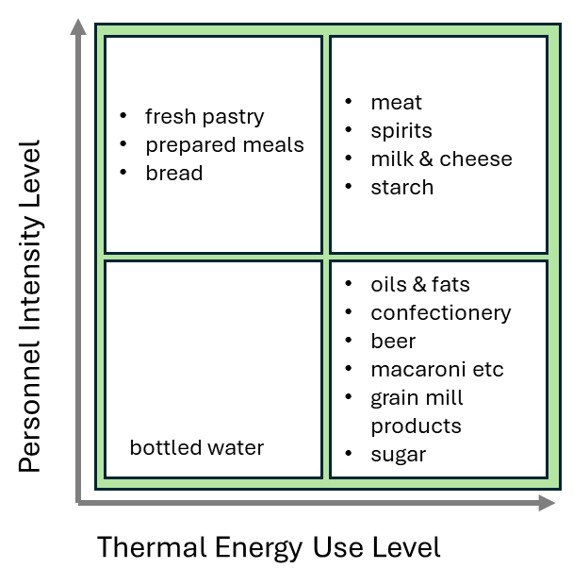

Introduction to End-Use Case Studies
To further assist Microsoft in analyzing Food & Beverage sector heat offtaker options, DGA developed five use cases which are diverse in terms of location, local demographics, and policy frameworks. While real-life details will influence payback periods, this analysis found that based on DGA’s assumptions, payback periods for offtakers would range from around 2 to 5 years. In the interview phrase of this project, several food & beverage leaders told DGA they like to see payback periods within approximately three years, so these figures are roughly in line with their expectations.
The payback periods for data centers (which incorporate the heat exchange room and electricity savings) are likely even shorter, based on significant OPEX savings on electricity that outweigh the initial CAPEX for the heat exchange room. Again, the financial details and data center payback period will depend on the specifics of Microsoft’s facilities.
The table below provides a high-level picture of the demographic and legal landscape of the use cases.
Table 4. Use case demographic and legal settings.
Case/Location | Nationwide: Population | Nationwide: Population Density | Site:  Population | Site:  Data Center Density | Relevant Considerations
Case 1: Germany (Frankfurt) | 85 M (Germany) | 241 | High | Very high | German Energy Efficiency Act
Case 2: UK (Newport) | 67.5 M | 277 | High | Rather high | Not EU
Case 3: The Netherlands (Amsterdam) | 17.4 M | 520 | High | Very high | EU EED
Case 4: Spain  (Madrid) | 46.6 M | 92 | High | Rather high | EU EED
Case 5: Sweden (Staffanstorp) | 10.6 M | 24 | Very low | Low | EU EED
Below is an overview of each offtaker’s type, size, and temperature needs, as well as key financial data.
Table 5. Offtaker type, size, and temperature needs, as well as key financial data for selected case study scenarios.
Case & Location | F&B Facility Type | Distance (data center to offtaker) | Data Center Temp | Offtaker Use Temp | Offtaker CAPEX + subsidy | Offtaker Payback Period
Case 1: Germany (Frankfurt) | Meat processing | 1.56 km | 30 °C | 80 °C | € 10.5M | 3.1 years
Case 2: UK (Newport) | Processed food | 15 km | 65 °C | 80 °C | € 10.0M | 2.2 years
Case 3: The Netherlands (Agriport A7) | Horticulture | 1 km | 55 °C | 55 °C | - | -
Case 4: Spain  (Zaragoza) | Beer | 3 km | 30 °C | 80 °C | € 5.6M | 3.6 years
Case 5: Sweden (Staffanstorp) | Oat milk production | 30 km | 30 °C | 75 °C | - | -
In several of the case studies, country-specific incentive programs can help improve the financials by supporting the purchase of heat pumps. More financial details can be found in the full Business Case Analysis deliverable (Word and Excel documents).

Case Study 1: Germany
Germany is a particularly relevant case study for Microsoft to consider, due to the German Energy Efficiency Act, which makes heat recovery mandatory. High consumer focus on sustainability in Germany also helps make this a strong market case—and a public relations opportunity—for Microsoft.

Selected Data Center
Digital Realty FRA11 (also called Interxion; east): Of the two Microsoft facilities in Frankfurt, this was the most suitable for a heat reuse project. The other— Equinix FR7 (west)—is so centrally located that piping would be difficult; additionally, no F&B sites are in its vicinity.

Selected Offtaker
Whilhelm Brandenburg GmbH & Co. (meat processing): The site has approximately 750 employees and produces 70,000 tons of meat annually. With a total thermal energy use of ~1,500 kWh/ton, Wilhelm Brandenburg is a large energy consumer (105,000 MWh/year). Its thermal demands include heating (roughly two-thirds of the thermal demand) and chilling (roughly one-third of the thermal demand).
Table 6. Estimated thermal energy distribution of Wilhelm Brandenburg.
Process | % of Thermal Energy | Annual Energy (MWh) | Average Power (MW)
Heating | 65% | 68,250 | 7.79
Chilling | 35% | 36,750 | 4.2
Total | 100% | 105,000 | 11.99
DGA’s scenario only considers heating, but it may be worth Microsoft investigating cooling compatibility as well.

Project Overview
Below is the relevant facility information for this case study:
- Distance to data center: 1.56 km
- Data center output temperature: 30°C
- Facility use temperature: 80°C

Business Case for the Offtaker
Offtaker Subsidies Available | Offtaker Financials
- CAPEX subsidy for large-scale heat pumps can cover up to 50% of the installation cost. | - CAPEX (including subsidy): €10.5M  - Payback period: 3.1 years
For the time being (until 2029 or 2030), the otherwise high electricity prices in Germany are capped at the EU allowed rate for manufacturers, 50 cents/MWh. The purpose of this cap is to compensate for price increases due to the war in Ukraine and to incentivize a transition from gas to electricity. This price cap improves the prospects for a heat reuse project in Germany.

Business Case for the Data Center
The table below shows the total CAPEX savings for the data center (compared with heat rejection through cooling towers):
Cost Component |  | Gain (€)
TOTAL |  | € 9,895,600
Cooling - Heat exchange room |  | € 9,658,000
Incentives estimate, 30% of CAPEX |  | € 237,600
The table below shows the total OPEX savings for the data center (compared with heat rejection through cooling towers):
Cost Component |  | Gain (€)
TOTAL |  | € 7,140,000
Maintenance, treatment, water savings |  | € 570,000
Power cost gain |  | € 963,600
OPEX subsidies |  | € 5,606,400

Case Study 2: United Kingdom

Selected Microsoft Data Center
Newport Imperial Park (Planned): The Imperial site has been approved but not built. Its two large data halls will support AI model hosting and cloud services and serve as a major component of the company’s United Kingdom (UK) AI infrastructure plan.

Selected Offtaker
Unilever Foods: The plant is situated in Crumlin, just north of Newport. Its operations should include pasteurization, cooking, CIP (clean-in-place), and packaging—all heat-intensive processes. A plant of this size needs between 6 and 10 MW of power, and it is most likely using natural gas today.
Table 7. Thermal energy breakdown for the Unilever plant.
Process | Temp Range (°C) | Description | % Thermal Demand | Power Need (MW) | 64°C Heat Match | Opportunity
Pasteurization | 70–90 | Heating sauces/spreads to kill pathogens; batch or continuous | ~25% | 2.0–2.5 | Yes | Ideal match—can use 64°C supply directly for continuous pasteurization
Cooking & Blending | 80–100 | Thermal processing of ingredients; includes emulsification and mixing | ~20% | 1.5–2.0 | Partial | May require heat pump boost; good for pre-heating or low-temp cooking
CIP (Cleaning-in-Place) | 60–85 | Hot water and steam for cleaning tanks, pipes, and fillers | ~15% | 1.0–1.5 | Partial | 64°C supply usable with minor upgrading; heat pump could close the gap
The 15 km distance between the two entities is relatively long. This makes the use case interesting as a challenge. As long as HDPE pipes can be used, there are no true physical or financial problems in overcoming this distance. With high projected rack densities at the Microsoft site, the case could benefit from implementing the 65 degree scenario, rather than 30°. For durability at this temperature, though, it might be necessary to use stainless steel piping. Stainless steel piping would increase costs, but likely not to the extent that it would threaten the business case.

Project Overview
Below is the relevant facility information for this case study:
- Distance to data center: 15 km
- Data center output temperature: 65°C
- Facility use temperature: 80°C

Business Case for the Offtaker
Offtaker Subsidies Available | Offtaker Financials
- Financial support in the UK is limited. The primary incentive identified is a £7,500 guaranteed grant per heat pump. | - CAPEX (including subsidy): €10.0M  - Payback period: 2.2 years  This high performing compute data center significantly improves the financial case by reducing the need for extensive temperature lifting with heat pumps.
The analysis shows the setup could be profitable within a reasonable timeframe, especially given high temperatures from the data center and the need for only one heat pump.

Business Case for the Data Center
The table below shows the total CAPEX savings for the data center (compared with heat rejection through cooling towers):
Cost Component |  | Gain (€)
TOTAL |  | € 9,895,600
Cooling - Heat exchange room |  | € 9,658,000
Incentives estimate, 30% of CAPEX |  | € 237,600
The table below shows the total OPEX savings for the data center (compared with heat rejection through cooling towers):
Cost Component |  | Gain (€)
TOTAL |  | € 8,874,480
Maintenance, treatment, water savings |  | € 570,000
Power cost gain |  | € 2,698,080
OPEX subsidies |  | € 5,606,400

Case Study 3: The Netherlands

Selected Microsoft Data Center
Agriport A7 Industrial Park: The park is home to Microsoft’s main data center campus in the Netherlands, as well as many greenhouses in need of thermal energy. DGA selected this use case over another Microsoft data center in Alkmaar (north of Amsterdam) because the closest F&B plant was 12 km away and topped out at 3 MW of thermal load.

Selected Offtaker
Agriport A7 Greenhouses: Greenhouses primarily need heat in the winter season, but the Agriport A7 industrial park is particularly eager to invest in heat reuse options, and more generally, to create an industrial symbiosis connecting agriculture and data centers.
Determining the ideal data center heat output is slightly tricky in this case, as neither 30°C nor 65°C is entirely appropriate. A 30°C supply is sufficient for low-temperature radiant heating or pre-heating irrigation water, but it is too low for direct air heating in winter—and the offtaker would therefore need a heat pump. A 65°C water supply is suitable for direct greenhouse heating, without a heat pump; however, using 65° water to heat greenhouses is wasteful and, therefore, not ideal for financial and environmental reasons.
The optimal temperature would be 55° C. Since the Agriport A7 site features both systems—low-temperature for radiant heating or pre-heating irrigation water, and slightly higher temperature for direct greenhouse heating—it would be easy enough to mix their waste streams ad libitum. This would minimize waste and avoid the need for a heat pump.

Project Overview
Below is the relevant facility information for this case study:
- Distance to data center: 1.0 km
- Data center output temperature: 55°C
- Facility use temperature: 55°C

Business Case for the Offtaker
Offtaker Subsidies Available | Offtaker Financials
- The SDE++ subsidy is a significant opportunity, offering up to €400 / ton CO₂ for waste heat projects. | - CAPEX: very low  - Payback period: N/A

Costs are minimal in this case study because there is no heat pump and because the route from the data center to the greenhouse is simple. Beyond the financials, this case is further driven by sustainability, community relations, and the benefit of securing building permits for future expansion.

Business Case for the Data Center
The table below shows the total CAPEX savings for the data center (compared with heat rejection through cooling towers):
Cost Component |  | Gain (€)
TOTAL |  | € 9,895,600
Cooling - Heat exchange room |  | € 570,000
Incentives estimate, 30% of CAPEX |  | € 237,600
The table below shows the total OPEX savings for the data center (compared with heat rejection through cooling towers):
Cost Component |  | Gain (€)
TOTAL |  | € 8,103,600
Maintenance, treatment, water savings |  | € 570,000
Power cost gain |  | € 1,927,200
OPEX subsidies |  | € 5,606,400

Case Study 4: Spain

Selected Microsoft Data Center
Zaragoza (Planned): Although Madrid appears to be a challenging area for largescale waste heat reclamation, Zaragoza is an emerging Spanish data center hub. Microsoft’s coming facilities here are part of the company’s broader European high-performance strategy and cloud expansion. Zaragoza is also home to several major F&B companies.

Selected Offtaker
La Zaragozana: The selected offtaker is a brewery (commercially known as Ambar Beers). The site produces beer, bottled water, and soft drinks; it is a major heat consumer in the 60–100°C range.
Table 8. Thermal energy breakdown for La Zaragozana.
Process | Temp Range | Thermal Load (MW) | Notes
Mashing | 62–72 °C | 1–2 MW | Converts starches to sugars; most energy-intensive step
Lautering | ~75 °C | Included in mashing | Separation of wort from grain
Boiling | 100 °C | 1–2 MW | Sterilization and hop addition
Fermentation | 10–20 °C | ~1 MW (cooling) | Depends on beer type (lager vs. ale); cooling required
Cleaning (CIP) | 70–85 °C | 0.5–1 MW | Hot water and caustic solutions used for sanitation
Malting (if on-site) | 50–65 °C | 1–2 MW | Germination and drying phases
All these processes (except for fermentation) would be suitable for waste heat use. Boiling would require a supplementary heat pump; in practice, the final temperature lift would probably be carried out with existing heaters.
Electricity prices in Zaragoza are moderate compared to other EU regions, making heat pumps economically viable. Natural gas is currently cheaper per MWh but also subject to price volatility and carbon costs under the EU ETS. The carbon tax in Spain is minimal for CO₂; most industrial emissions are regulated under the EU ETS.

Project Overview
Below is the relevant facility information for this case study:
- Distance to data center: 3.0 km
- Data center output temperature: 30°C
- Facility use temperature: 80°C

Business Case for the Offtaker
Offtaker Subsidies Available | Offtaker Financials
- The IDAE provides CAPEX subsidies of up to 50% for large-scale industrial heat pumps (35% for the pump, 15% for installation). | - CAPEX (including subsidy): €5.6M  - Payback period: 3.6 years

Business Case for the Data Center
The table below shows the total CAPEX savings for the data center (compared with heat rejection through cooling towers):
Cost Component |  | Gain (€)
TOTAL |  | € 9,895,600
Cooling - Heat exchange room |  | € 9,658,000
Incentives estimate, 30% of CAPEX |  | € 237,600
The table below shows the total OPEX savings for the data center (compared with heat rejection through cooling towers):
Cost Component |  | Gain (€)
TOTAL |  | € 8,010,880
Maintenance, treatment, water savings |  | € 570,000
Power cost gain |  | € 1,734,480
OPEX subsidies |  | € 5,706,400
A Note on Future Projects
East of Zaragoza, in Villanueva de Gállego there is a planned agri-food and tech development zone, Centro Logístico Agroalimentario del Valle del Ebro (CLAVE). It will be home to the Costa Group meat complex, a large-scale pork processing and distribution hub expected to employ up to 3,000 people. Taking advantage of waste heat for its industrial processes would be a logical step.

Case Study 5: Sweden

Selected Microsoft Data Center
Staffanstorp: This site is in the Skåne (Scania) region, near Malmö and Denmark. Skåne's fertile soil has made the region an important F&B actor. Microsoft has announced plans for more data centers in southern Sweden. Given the number of F&B facilities nearby and the prospects of additional data centers in the area, DGA chose Staffanstorp for this analysis. Other locations of existing Swedish data centers were not feasible due to the lack of F&B facilities nearby.
Electricity prices in Sweden are relatively low for industrial users, especially in SE4 (which includes Staffanstorp). So, in contrast to the UK case, locating a data center does have implications on power cost.

Selected Offtaker
Oatly: The beverage company has its main production plant 30 km from the Staffanstorp facility. Not only does Oatly have a use for the heat energy; it is also a highly sustainability-focused company, so it would be a good partner for Microsoft’s efforts. There is a longer distance (30 km) between the Oatly site and the data center—pushing the boundaries of what is typically considered for heat reuse. The length makes the piping costs difficult to estimate; still, if OPEX savings are high enough, such a distance may be acceptable.
Additionally: because Sweden already uses waste heat, biofuels, and electricity for their heat needs, this case assumes data center heat would not offset gas use.

Project Summary
The financial analysis for Sweden is a special case, as there is no natural gas to replace. Further investigation would be needed to judge its feasibility. Still, it should be said that Sweden is already a leader in waste heat reuse projects, and would likely be open to additional waste heat where needed.
Below is the relevant facility information for this case study:
- Distance to data center: 30 km
- Data center output temperature: 30°C
- Facility use temperature: 80°C

Business Case for the Offtaker
Offtaker Subsidies Available | Offtaker Financials
- CAPEX support is available from the Swedish Energy Agency and EU programs. | - CAPEX (not including subsidies): €19M  - Payback period: N/A

Business Case for the Data Center
The table below shows the total CAPEX savings for the data center (compared with heat rejection through cooling towers):
Cost Component |  | Gain (€)
TOTAL |  | € 9,895,600
Cooling - Heat exchange room |  | € 9,658,000
Incentives estimate, 30% of CAPEX |  | € 237,600
The table below shows the total OPEX savings for the data center (compared with heat rejection through cooling towers):
Cost Component |  | Gain (€)
TOTAL |  | € 7,910,880
Maintenance, treatment, water savings |  | € 570,000
Power cost gain |  | € 1,734,480
OPEX subsidies |  | € 5,606,400

Beyond 8 MW
Both the technical system and the cases presented in this report are for an 8 MW offtaker, as that seems to be a realistic picture of large F&B companies’ needs. For existing and planned hyperscale data centers, this figure may be undesirably small. There may, however, be ways to alleviate this challenge, such as:
- Supplying heat to industrial parks. In industrial parks with one dominant data center and several potential heat offtakers, it may be possible to scale up heat reuse, in essence by acting as a district heating provider.
- Supplying heat to several facilities within a corporation. An ideal scenario for Microsoft could be to serve as the single supplier of thermal heat for one of the world's largest F&B corporations (Nestlé, Unilever, Tyson Foods, Mars, Mondelez, Danone, etc.). That would bring not only more heat reuse possibilities for a specific site, but also exciting opportunities for growth. Working with multiple facilities from a single company would provide economies of scale and learnings—both technical and legal—from each installation.
- Offer cooling. It is estimated that 30% of the European F&B sector’s energy consumption stems from cooling. In Europe, the cold supply chain—which includes refrigeration during transport, processing, and storage—is considered one of the most energy-demanding systems in the F&B sector. In the dairy industry specifically, cooling and refrigeration are among the top energy-consuming processes. This presents another possible opportunity for Microsoft’s heat reuse partnerships.
- Noting the difference between boilerplate and true use. Hyperscale data centers are typically provisioned for 100 MW or more. However, actual average IT load tends to be much lower—often 40–60% of provisioned capacity depending on the facility’s age, design, and workload patterns. Even in highly optimized hyperscale environments, idle capacity is common. For example, a 100 MW data center might only be drawing 50–60 MW on average, with the rest reserved for peak demand, redundancy, and future expansion. With that in mind, what may seem like a 25% reuse scenario (for a 20 MW data center) is, in reality, a 50% reuse scenario.

Interviews with Potential Food & Beverage Offtakers
The following section offers insight into the feasibility of data center heat reuse based on the DGA team’s interviews with seven major food & beverage manufacturers, all of which have a presence in Europe.
The goals of the interviews were to:
- understand the attributes of a company’s heating needs—including their temperature range, consistency requirements, and primary applications—and determine if those needs may be suitable for a waste-heat partnership; and
- gauge the company’s interest in data center heat reuse, including any key obstacles they would need to overcome before implementing a project.

Methodology
Interviews took place from July to September 2025 and included sustainability and technical leaders from companies that represent billions in revenue and temperature applications ranging from approximately 30-200°C. Each interview lasted approximately one hour. DGA used the same general framework for each interview but allowed the conversations to flow freely. To encourage an open and comprehensive exchange, DGA agreed to anonymize the results of the interviews in this report. The interview subjects likewise agreed to keep the details of DGA’s work for Microsoft confidential within their immediate team.

Key Takeaways
Perhaps the most exciting takeaway from DGA’s interviews was the widespread openness among F&B leaders to using data center waste heat. Interview subjects were quick to share the applications they thought would be most suitable—largely, this turned out to be cleaning, process heat, and pasteurization, which need water around 60-90°C.
The companies’ facilities run the gamut in terms of size, but several are quite large, and most operate either 24/7 or close to it. Additionally, all seven of the companies have implemented at least one heat pump in Europe, providing technical experience that will make heat reuse partnerships more feasible.
Some companies did have questions about the practicalities of heat reuse—such as the specific volume of waste heat they would receive or the capital expenditures required—but many companies expressed concrete interest in having further discussions with Microsoft.
When it comes to finances, interviewed companies prefer to see returns on capital investments within about three years. However, more than one interviewee mentioned that timelines could be slightly more flexible if projects had a sustainability element. Crucially, many of the interviewed companies are sustainability leaders, and—combined with the pressures from European regulations—appear to be proactively searching for any innovative tool that will help them cut carbon emissions while growing their business.
Key findings from DGA’s interviews are presented below across four main categories: market opportunity scale, compatibility, partnership readiness, and financial models. Additional details from the F&B interviews can be found in the full Interview deliverable.

Market Opportunity Scale
The companies interviewed range from small-scale distributed partnerships (a company with six European facilities with 1,000-100,000 GJ annual demand) to industrial-scale opportunities (a company consuming up to 300 MW thermal load). Combined, these partners offer sufficient scale to absorb waste heat from multiple large data centers while providing geographic distribution across key European markets.

Heat Compatibility
All the companies DGA interviewed have at least some heating applications that would be compatible with data center waste heat (typically at 30-50°C when leaving the data center) if paired with heat pumps. Thie most suitable processes—mentioned by five companies—include cleaning and process heat which require water in the 60-80°C range. Two companies also mentioned pasteurization, which requires heat at about 90°C. Only one company—Company G—said it might be able to use heat directly from a data center without a heat pump, to pre-heat water.
Companies also have higher temperature heat or steam needs of 150° and above for processes like roasting, drying, and baking. At least for the time being, these are not practical applications for heat reuse projects. Most interviewed companies operate 24/7 or close to it, which helps their demand profiles to match data center output.

Technical Experience
All of the seven companies interviewed are already using heat pumps at least one facility in Europe. One is in a pilot phase, but the rest have fully operational heat pumps. This technical experience—and the openness to heat pumps—can help these companies prepare to integrate data center waste heat. Multiple companies indicated they could integrate a data center project into existing heat pump infrastructure. More specifically:
- Company D (a food & beverage company) explained that the more energy you can bring into the system, the less work the heat pump has to do.
- Company G (a specialized beverage company) has a “standard heat recovery” system that it builds into all new facilities, and it is exploring retrofits of older sites.
- Company F (a chemicals and fragrance company) noted that it has established a cooling loop at some European sites.
Only one company—Company E—has already implemented heat reuse projects with external partners. In France, the company has an agreement with a neighboring stream producer, which uses direct piping to deliver heat. And in the UK, the company’s facility gets 90% of its heat from an adjacent utility generating system.

Partnership Readiness
Interviewees consistently expressed enthusiasm and were intrigued by the idea of using data center waste heat. These companies have ambitious sustainability goals—and some noted that they have exhausted the “low-hanging fruit” to decarbonize their facilities, leading them to seek innovative new ideas. For example:
- Company A said it is very open to new solutions and thinks waste heat could be part of efforts to meet its decarbonization goals.
- Company B noted that as a commodity company, efficiency is in its DNA. It is looking for “dark horse” solutions like heat reuse which might make a big difference but aren’t widespread yet.
- Company D said the next step would be to sign an NDA with Microsoft and share details on facility locations, exact heat needs, and other key details. The company noted that it could either pursue a smaller proof-of-concept project or move directly to bigger project, depending on interest and feasibility.
- Company F told DGA that if there is a conveniently located data center, there is “definitely an interest to see if we can use this waste heat between neighbors.”
Companies identified certain questions they would like answered before proceeding with projects. At a basic level, companies noted they would need to know the exact temperature and quantity of heat coming from Microsoft’s data centers. Others noted they would need to ensure the waste heat would be reliable. Company C (a confection and pet food company) noted that if it loses heat supply for sterilization processes, it would shut the factory down for 10-12 hours, costing the company millions of dollars. Although Microsoft is unlikely to be supplying heat that is hot enough for sterilization at present, the loss of a heat source can have serious ramifications for an offtaker’s business. Meanwhile, Company E noted that due to its requirement that all new energy sources be zero- or low-carbon, it must understand whether Microsoft’s waste heat could be considered as such.

Financial Considerations
Investment approaches for capital projects vary from company-to-company. Most told DGA that they have conservative payback periods of roughly three years, but several noted that projects with a sustainability element may be able to stretch that timeline. One company however—Company D—said it would use a 15-20 year return on investment (ROI) horizon for projects like waste heat reuse, explaining that leaders prefer comparing project costs to alternatives, like other renewable fuel options, rather than the cost to “do nothing.” This company further noted that it has funding set aside for heat pumps. Finally, four companies specifically told DGA they have funding set aside for sustainability projects.
Additional insights from interviewed companies include:
- Company G noted that sustainability is “baked into” its mission and sustainability benefits can help tip the scales toward a project, allowing leaders to extend the payback period beyond three years.
- Company F says it will devote capex to decarbonization, though it prefers to spend money on its core functions. Notably, Company F expressed interest in pay-as-you-go/utility-as-a-service approaches; for example, it contracted with a company to install and operate a biomass boiler. After a 10-15 commitment, the company will own it. Company B also expressed interest in energy-as-a-service partnerships.
- For its own capital, Company E typically requires three year payback periods, but when the main purpose is not just cost savings but decarbonization, the calculus has “a little bit more flexibility.” The company evaluates projects based on cost per ton of CO₂ reduced. It also likes to see big impacts from a project, noting that it might not consider something like a rooftop solar hot water project if it only helps with 2% of thermal load.
- Company D has funding set aside for heat pumps, seeing it as a “step change in performance.”
- Company A noted that when implementing clean energy technologies, including heat pumps, the biggest challenge is the payback period. The company also said it is interested in seeing pilots, as this helps leaders to see potential and understand challenges.

Company Overviews
The food & beverage companies interviewed as potential data center waste heat offtakers operate facilities across the EU, with temperature applications at 30°C and above. The table below provides a summary of their temperature needs, heat demand, and location. As noted above, additional detail, including more extensive company profiles of interviewees, can be found in the separate Interview deliverable document.
Table 9. Company Overviews of Interviewed Companies
Company | Temperature Needs | Heat Range Demand | Geographic Spread
Company A | 60-100°C for most processes (including industrial hot water); 80-130°C for some higher temperature food processes like drying | 1.2 TWh/year, with 60% from thermal | 35 facilities throughout the EU
Company B | A “large need” for “low-temperature heat,” below 93°C at protein sites as well as higher 93-149°C uses | Up to 300 MW thermal load | Netherlands, Germany, France, Italy, Spain
Company C | 60°C for pet food;  90°C for human food;  up to 180°C for drying | 400,000-700,000 GJ of heat per ton/year | Germany (7), France (4), Netherlands (1), Italy (1)
Company D | 90°C for beverage steam pasteurization;  200°C for processes like frying | 18-24 MW per facility | Portugal, Spain, Belgium, Poland, UK
Company E | 80-90°C for process heat;  150°C for frying;  150-175°C for steaming canned foods | Moderate industrial scale | Czech Republic, France, Germany, Netherlands, Poland, UK
Company F | 60-80°C for low heat;  150-200°C for high heat | 1,000-100,000 GJ per site | Geneva, Zurich, Netherlands, Spain, Italy, UK, Germany
Company G | Can use 30-50°C heat for pre-heating water; 90-140° for cleaning and processing | 30-60 million kWh of natural gas | Sweden, Netherlands

Conclusion
As noted throughout this report, each piece of analysis supports the conclusion that offtaker companies are ready to partner with Microsoft on data center waste heat reuse projects, and food & beverage facilities provide significant potential as a starting point. All of the food & beverage companies that DGA interviewed expressed a willingness to further explore partnerships with Microsoft.
DGA would be happy to support next steps in this effort, including but not limited to expansions of the Business Case Analysis, facilitating connections between Microsoft and interviewed F&B companies, or expanding analysis to additional potential heat offtake sectors. Data center waste heat reuse is technically and financially feasible, and Microsoft has a significant opportunity to be a leader in this new solution.

Appendix

Heat Reuse Flow Diagrams
The flow diagrams below provide a visual explanation of the heat reuse scenarios used in the Business Case Analysis.

Figure 5. Heat leaves the data center at 30°C and is used at 80°C.
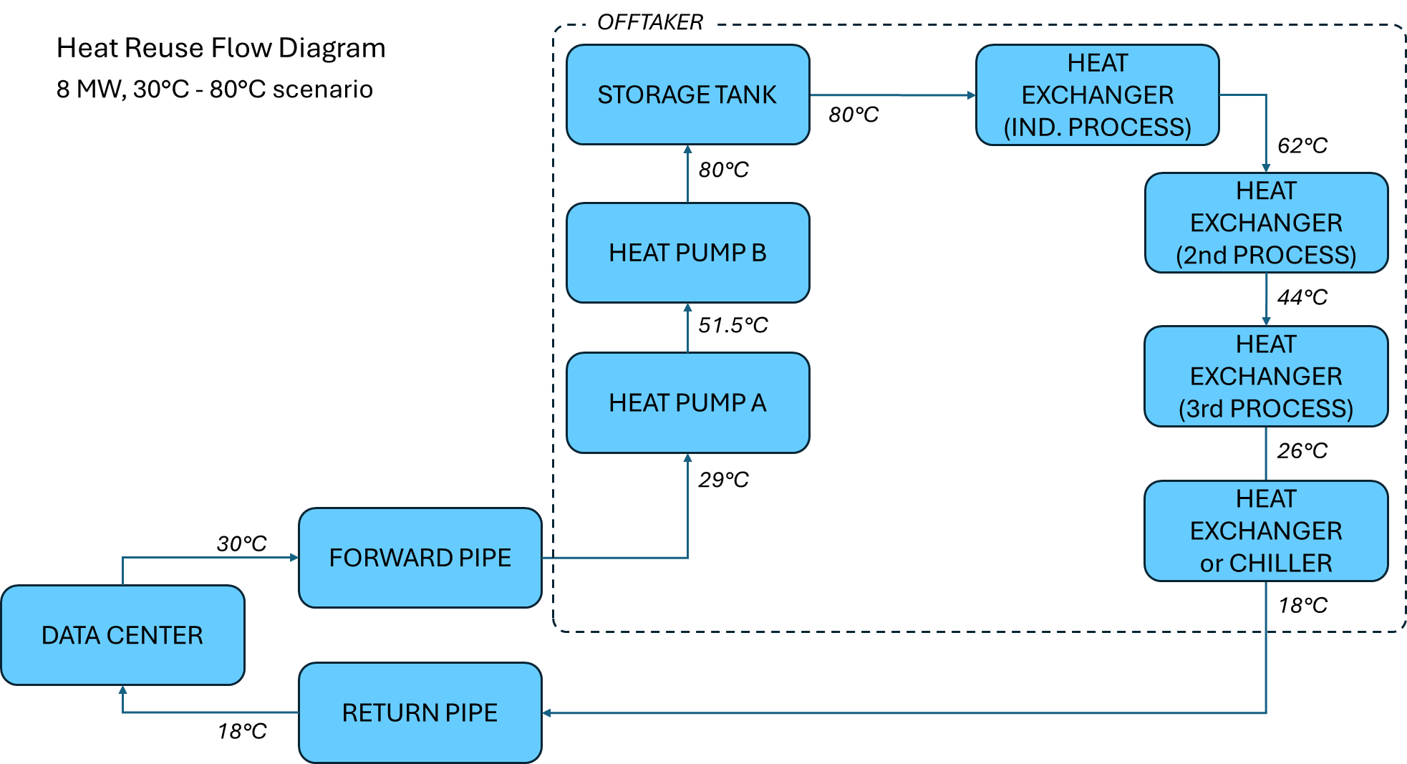

Figure 6. Heat leaves the data center at 65°C and is used at 80°C.
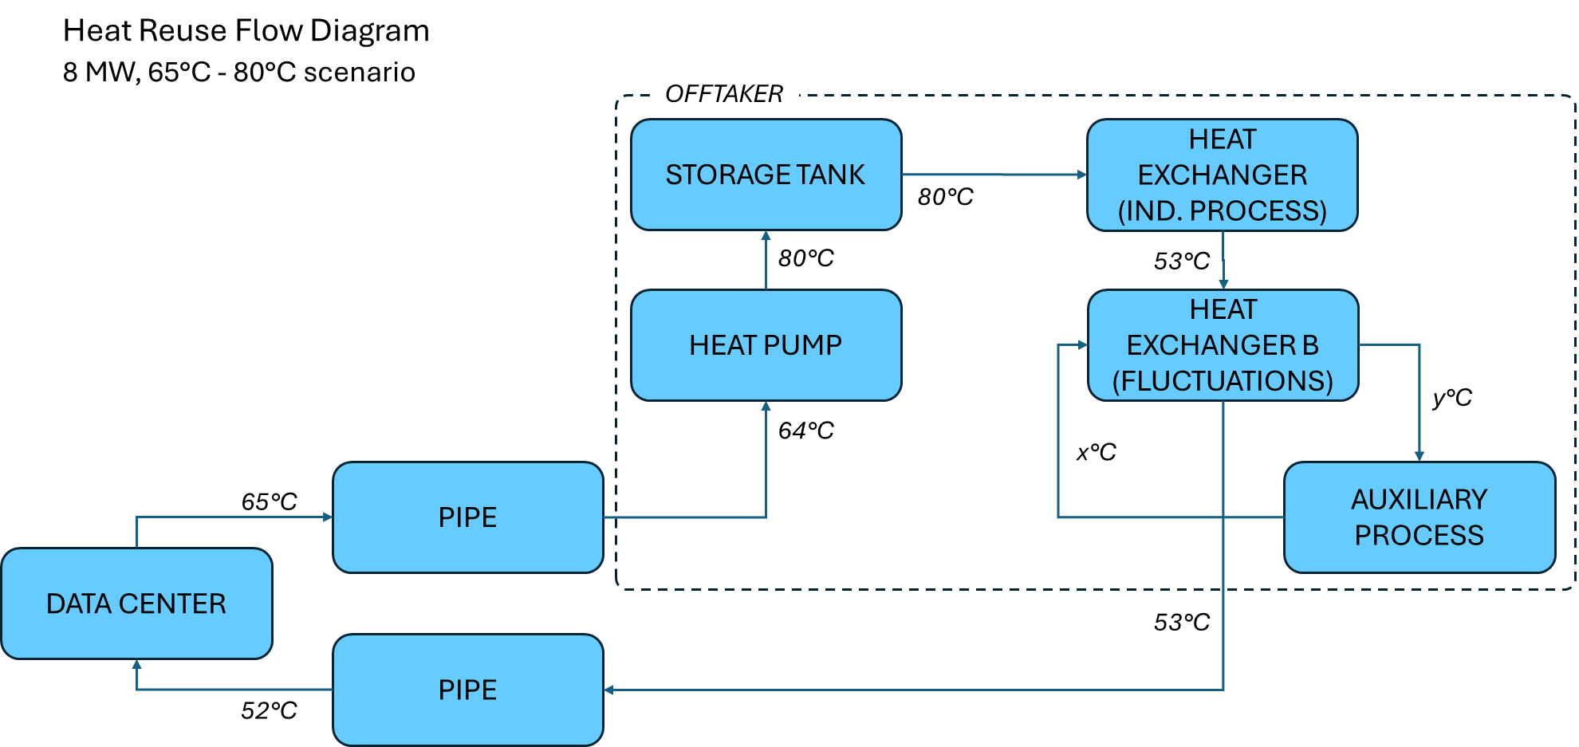

Figure 7. Heat leaves the data center at 65°C and is used at 64°C (temperature loss of 1°C, with no temperature lift needed).
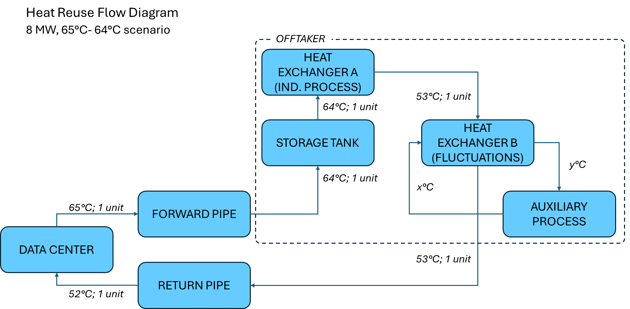

Naschert, Camilla and Susan Dlin, “European data center power demand to double by 2030, straining grids,” S&P Global, July 30, 2025.
Smith, Brad, “Microsoft announces new European digital commitments,” April 30, 2025.
“4 Innovative Ways to Harness Waste Data Centre Energy.” Data Center Waste Heat, World Economic Forum, www.weforum.org/stories/2024/02/harnessing-waste-energy-data-centres/. Accessed 10 Sept. 2025.
Technavio, Industrial Heat Pumps Market Analysis Europe, APAC, North America, Middle East and Africa, South America - US, Italy, China, Japan, Germany, UK, Canada, India, France, Brazil - Size and Forecast 2025-2029.
BMWK Newsletter Energiewende - Relief for manufacturing and energy-intensive companies
https://local.microsoft.com/blog/newport-imperial-park-datacentre-construction-overview/
https://ambar.com/fabrica-cerveza/
For reference, here is Oatly’s sustainability report for 2024: https://a.storyblok.com/f/107921/x/cbdb92c917/oatly-sustainability-update-2024.pdf
JRC Science and Policy report. Energy use in the EU food sector: State of play and opportunities for improvement (2015). https://publications.jrc.ec.europa.eu/repository/bitstream/JRC96121/ldna27247enn.pdf

